**Experiment : 8**

**Title :  Observe and understand the process map of the previous two lab programs (Experiment 6 and Experiment 7)  using pmap command.**

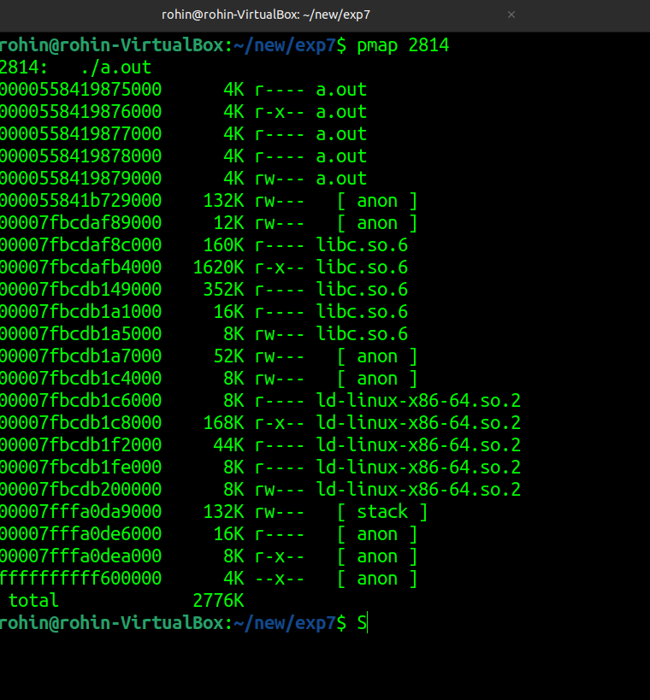**Outputs: Exp 6**

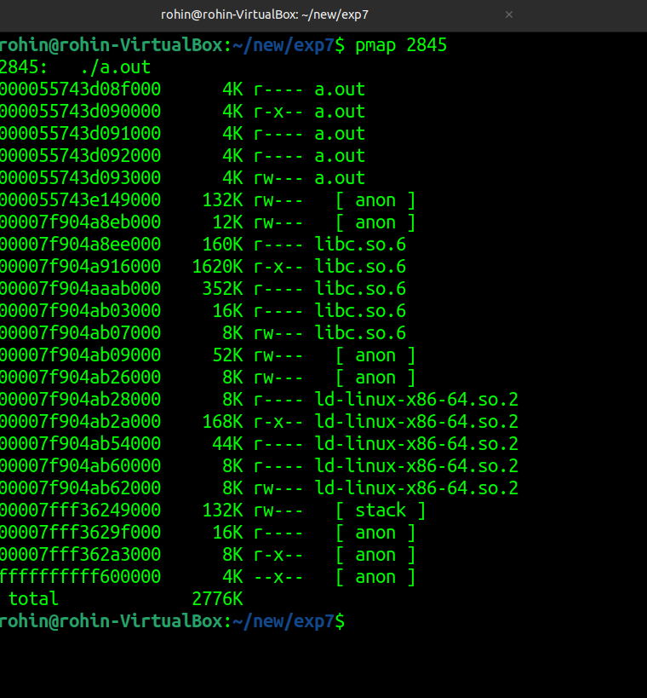

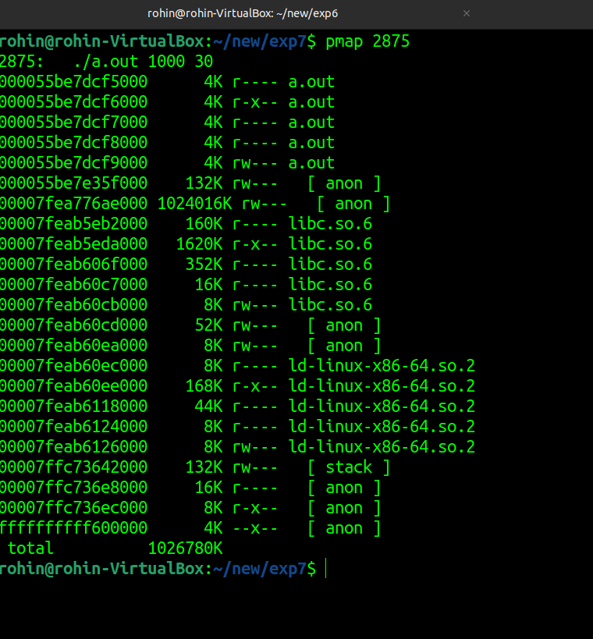**Exp 7**